CSC 4330: Software Systems Development

Project: Data Parser to Automate Calendar Event Generation

Members:
Hunter Dupré
Don Hunter
Amir Norouzi
Harrison Robichaux
David Vennen

System Design Description

Table of Contents:

Preface: 3
Project Description: 3
Section 1: Architectural Design 4
Architectural Pattern Selection: 4
Architecture Justification: 4
Section 2: Detailed Architecture Models 6
Structural Models: 6
Class Diagrams 6
Component Diagram 11
Interaction Models: 12
Sequence Diagrams 12
Activity Diagram 15
Section 3: Project Prototype 16
Glossary: 19

Preface:
This project is a key part of a Software System Development course taught at Louisiana State University. The goal of the project is to gain software engineering experience through a practical, hands-on approach. Teams will utilize concepts taught in the course to fully embody the Software Development Lifecycle, ideally becoming familiar with the process and the associated SDLC models that are used in the industry.

Project Description:
This project is a data parser that identifies and separates key event dates from various file types, and utilizes the data collected to automatically create scheduled calendar events. The purpose of this project is to provide a quick, streamlined process to automatically compile a calendar based on timeframes and deadlines provided through multiple, often unrelated, sources. This will reduce manual overhead management for daily life, and as such provide a large quality of life benefit.

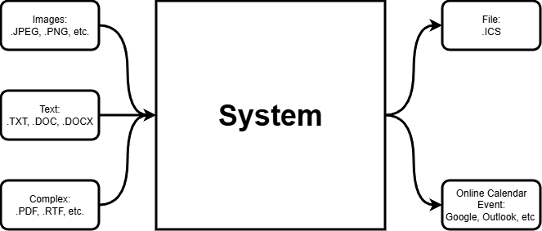

Section 1: Architectural Design

Architectural Pattern Selection:
The architectural pattern this project utilizes is primarily a Pipe and Filter system, with some aspects taken from an MVC architecture.

Architecture Justification:
Due to the incremental nature of the development of our system, a Pipe and Filter approach was critical to the design process. Our overall system involves the following subsystems: File Collection/File Validation, Method Selection for Data Extraction, Text/Image Parsing, Contextualize Data, Calendar Event Creation.
- File Collection/Validation – Gathers input files from the user and ensures they are a valid filetype for processing. Serves as the entry point of the pipeline.
- Data Extraction Method – Converts raw input files into readable text-based content using appropriate extraction techniques per file type.
- Text/Image Parsing – Analyzes extracted text to identify and locate date/time information.
- Contextualize Data – Interprets the collected date/time data and correlates them with the context of surrounding textual data to derive meaningful related information.
- Calendar Event Creation – Transforms the contextualized data into a calendar event object and prepares them for export.
Because each subsystem is sequentially dependent on the successful execution of the previous subsystems, we can divide the concentration of workflows to each key function. Once those pieces are completed, we can keep each of their respective data launch and capture points separated for future improvements. This keeps the overall architecture largely modular and maintainable.
To ensure that the system is usable, and its features are discoverable, we also decided to implement some form of user interface. With the user interface it was important to consider how the system would be represented to the user on the front-facing side, and how the system would work on the backend. As we are in the process of finalizing our ideal user interface, we are preliminarily utilizing an ImGui graphical interface which is minimalistic.
Going forward, the system will inherit a partial MVC architecture as the focus will be on the visualization of the interactions between the user input and system, the system’s subsystems to themselves, and the final product presented from the system back to the user. In this case, the system operations from pipelined sections 3-5 (as shown on previous page) is considered the model, responsible for managing the data and calculations of the system; the front-end user interface is considered the view as it serves as the direct link for interactivity between the user and the system; and the pipelined sections 1&2 of the system is the controller, which responds to the user input by sending the collected input to the core system, identified as the model.

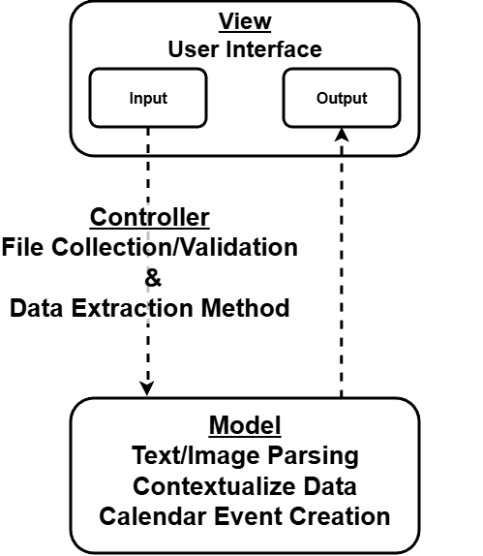

Section 2: Detailed Architecture Models

Structural Models:

Class Diagrams-
In the following diagrams, filled circles show strong ownership of attributes, empty circles show weak ownership, filled squares indicate that the class creates another class, and the empty squares indicate a dependency on another class.

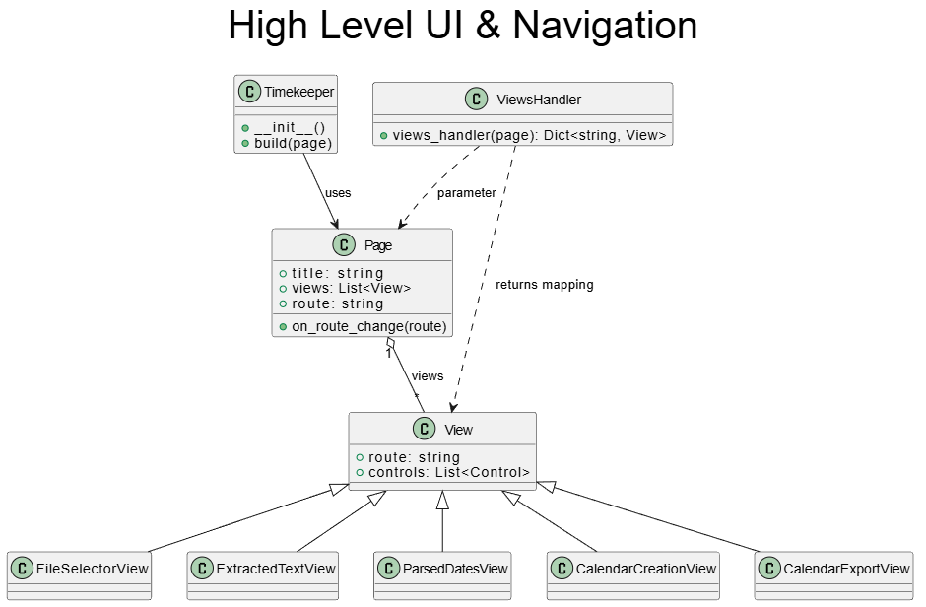
High Level UI & Navigation:
Controls the flow of the applications and manages screen states. Initializes UI and builds routes for navigation. Each view represents a screen in the application.

File Selection & Data Extraction:
Handles all input files from the user and determines how they should be processed.

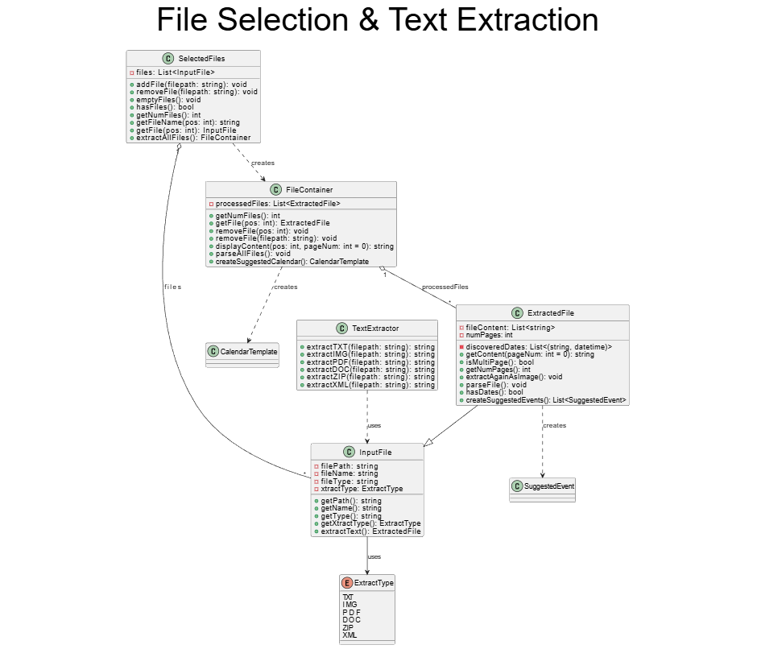

Date Parsing and Event Suggestion:
Processes natural language and utilizes pattern recognition to add context to the suggested events to export to calendars. This context includes the date, time, title of the event, description and location.
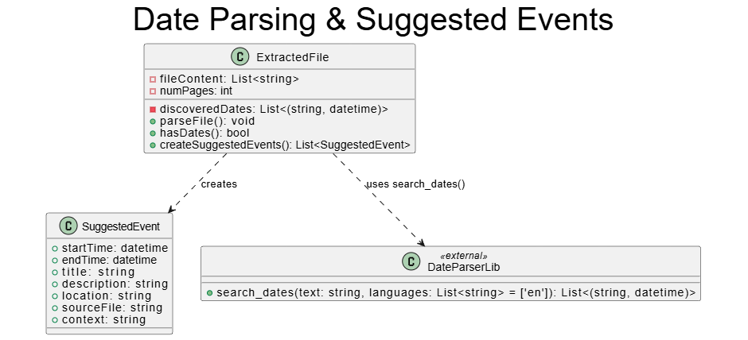

Events and Calendar Creation:
Allow the users to validate the information retrieved from each source before moving onto exportation of the calendar event items.
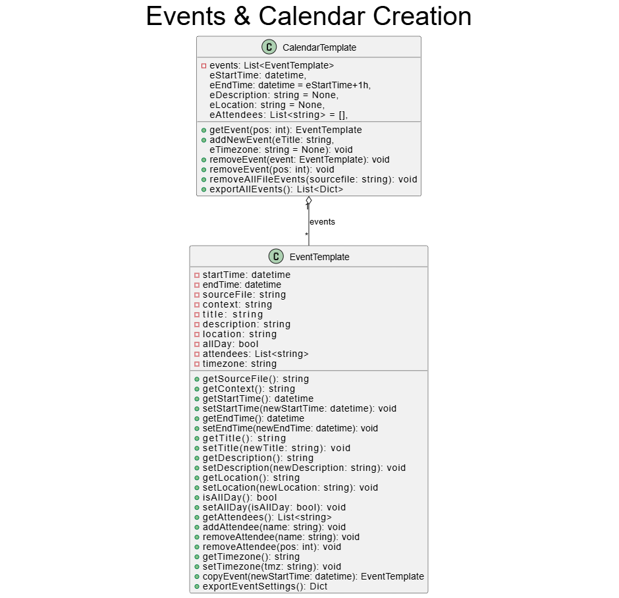

Calendar Export:
Converts the finalized events into calendar formats, then shares links and/or creates .ics files.
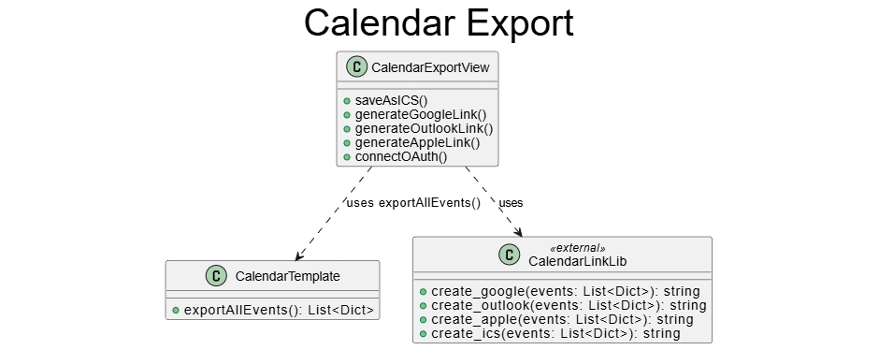

Component Diagram-
Component diagram is an illustration of the pipeline architecture essentially. Shows each component, from input to output, and the corresponding flow of data being passed from component to component.
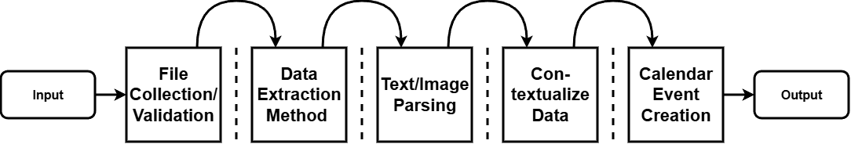

Interaction Models:

Sequence Diagrams-
In the following diagrams purple rectangles represent objects, solid arrows represent messages, dotted arrows represent return messages and vertical dotted lines represent lifelines.

File Selection & Text Extraction
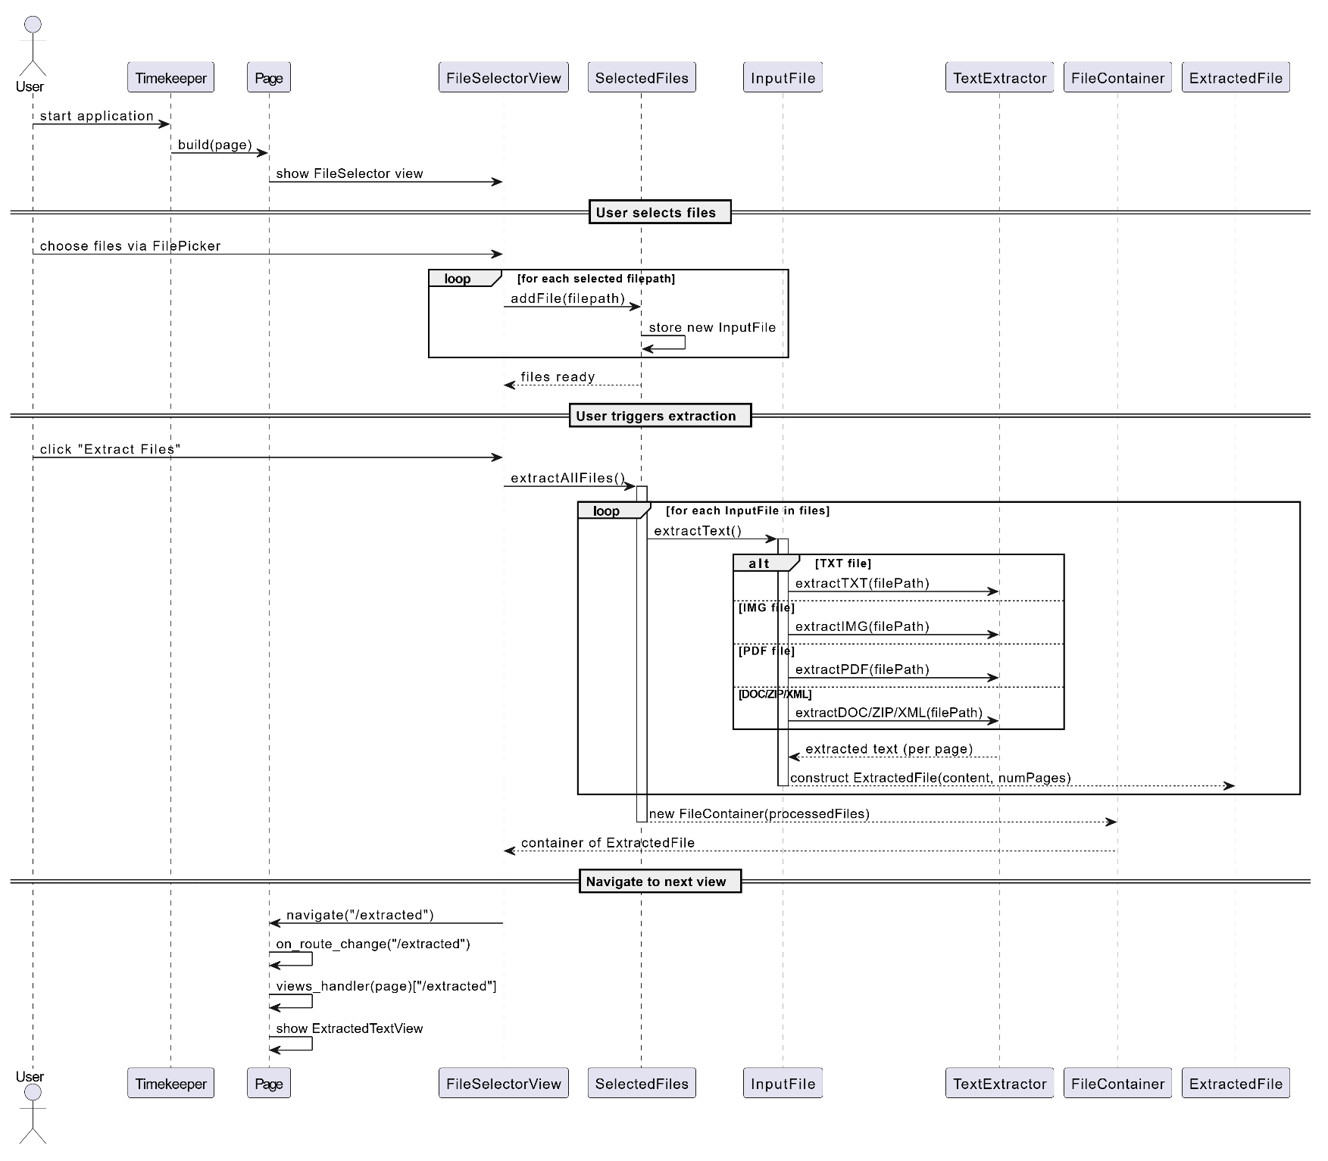
The system waits for the user to upload a file. Once uploaded, the system adds the file to the file path and stores them in inputFile. Then the system waits for the user to click on a button to start text extraction. The system loops through each input file and extracts the text from each file.

Parse Dates & Build Calendar
A container of extracted files is sent to parseFile where a loop uses pattern matching to parse dates and other important event data like title, location, and reoccurrence.
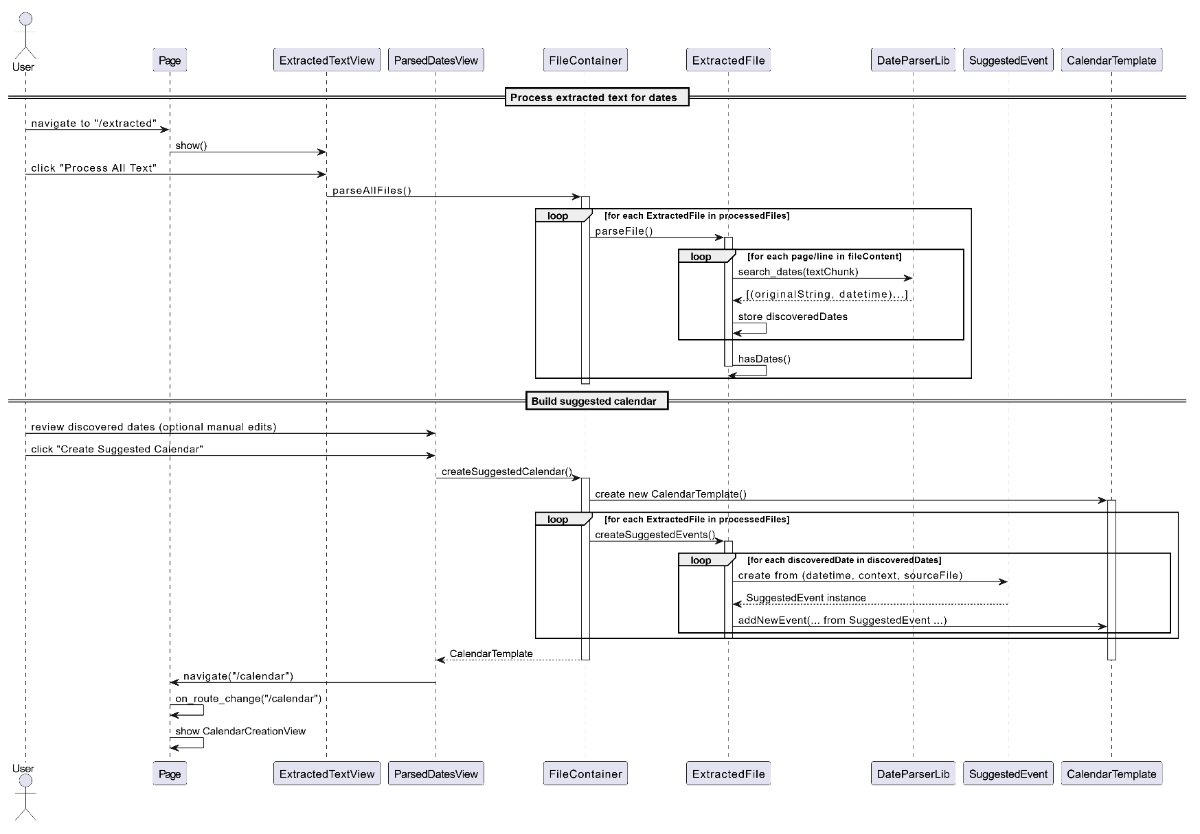

Edit Events & Export Calendar
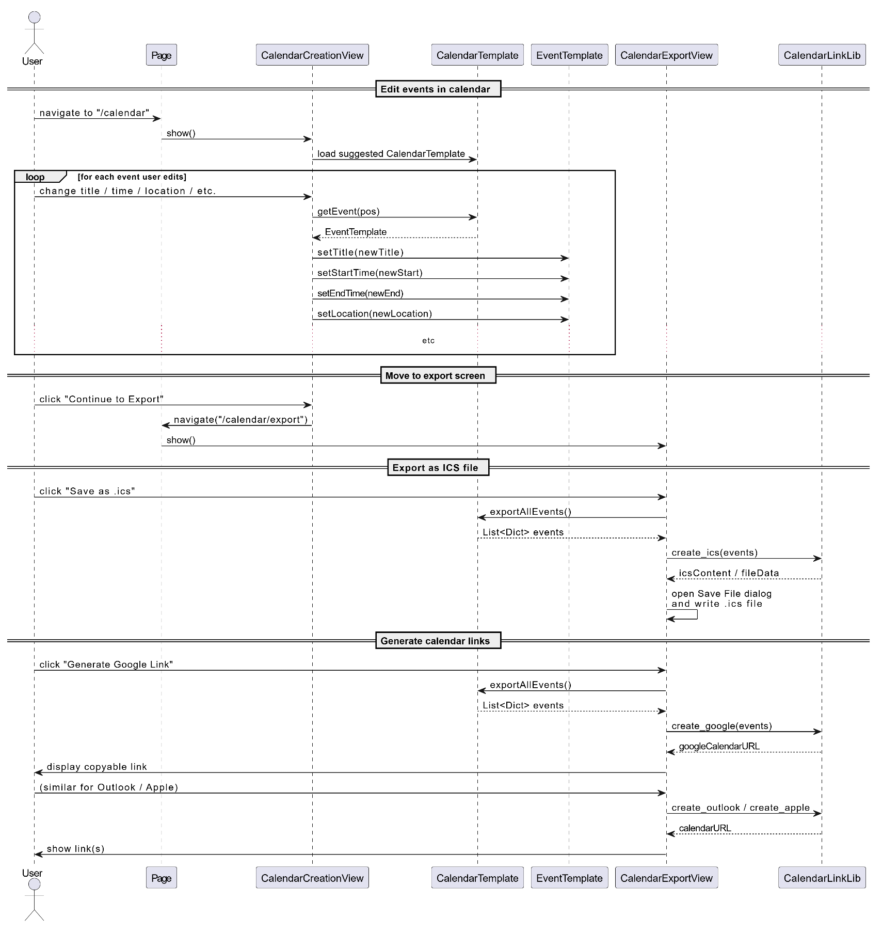
A genericEvent is created from the collected date time information, users can then edit events if they so desire. Once approved, the events are turned into .ics files which can be saved to a calendar app of their choice.

Activity Diagram-
The following diagram uses filled dots to represent start states, arrows to represent control flow, rectangles to represent actions, rhomboids and hexagrams to represent merges or decisions and filled dots with circles to represent final states. 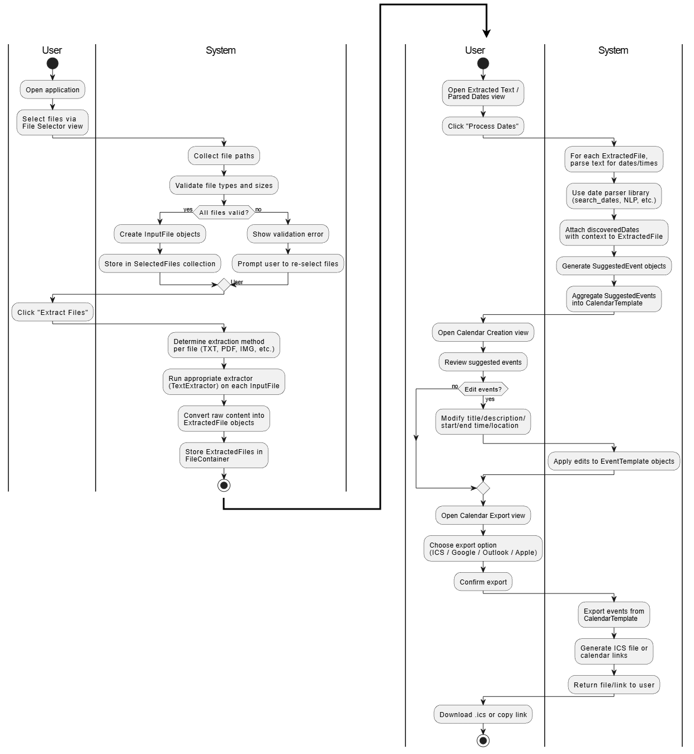

Section 3: Project Prototype

See example prototype still frames below for visual reference.
The current prototype UI is a primitive viewport utilizing ImGui. The goal is to update visually as functional features are added.
The program waits for the user to upload a file. Once uploaded, the program adds the file to the file path and stores them in inputFile. Then the system waits for the user to click a button to start text extraction. The system loops through each input file and extracts the text from each file. Suggested events are then created from the extracted text. Generic Events is then passed a container of extracted files and loops through each file creating Generic Events. Those Generic Events are passed to iCalCreator which creates .ics files from the generic events, that the user can use to create events in the calendar app of their choice. 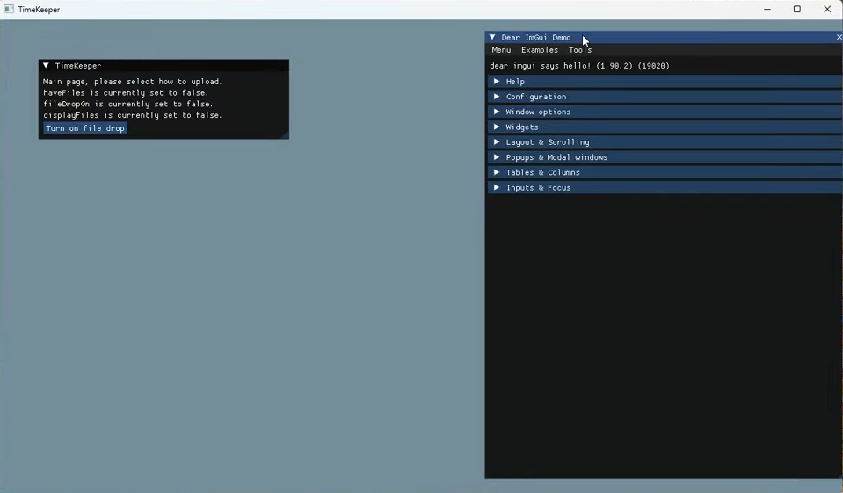
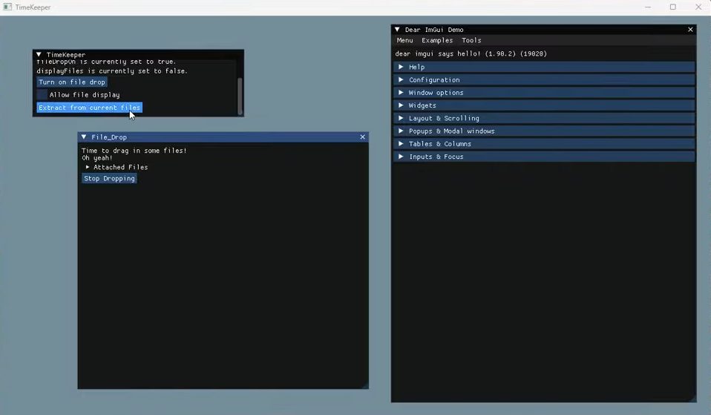

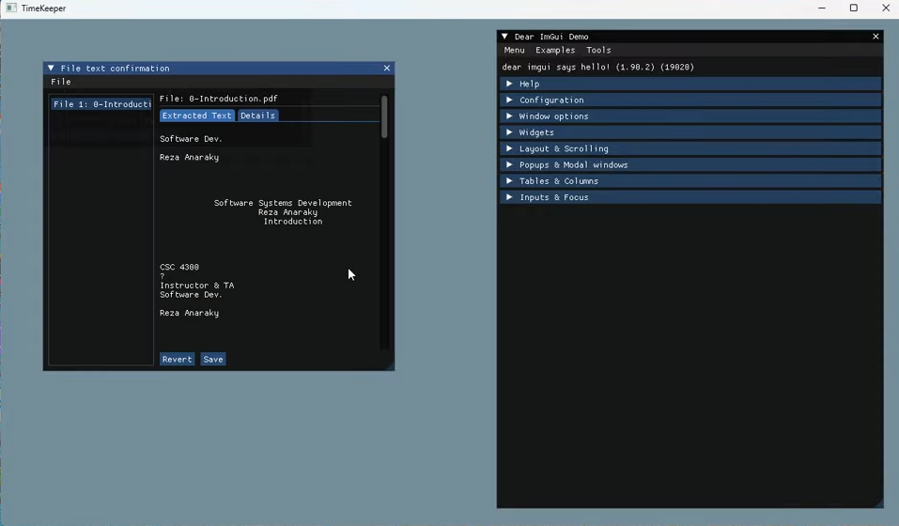
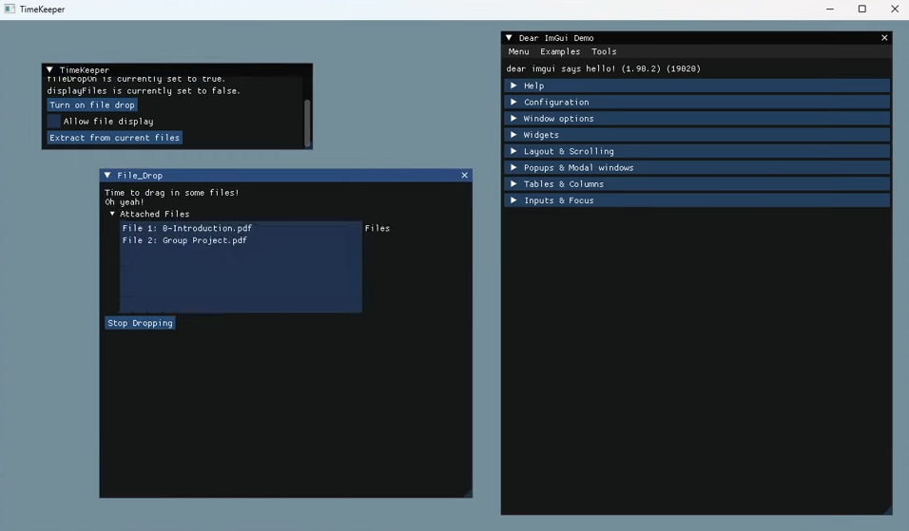

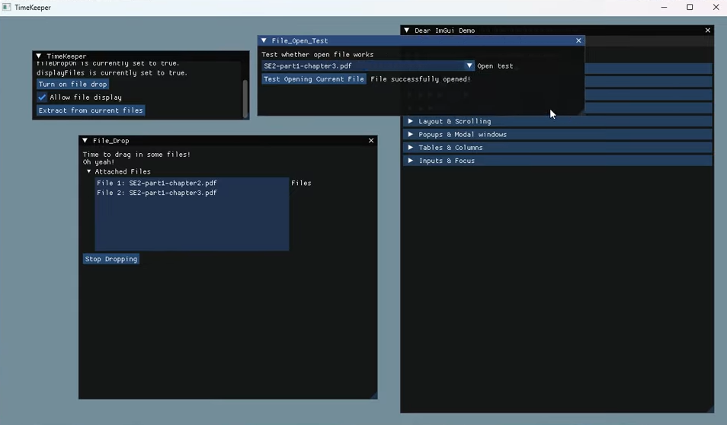

Glossary:
Activity Diagram
A flowchart that shows the steps a user or system goes through to complete a task, from start to finish. It uses arrows and boxes to show how the process moves from one action or decision to the next.

Architectural Pattern
A blueprint for how the main parts of a software system are organized and how they talk to each other.

Backend
The behind-the-scenes part of the system that the user does not see.

Calendar Event
An item that appears on your calendar, such as a meeting or deadline. It usually includes a title, date, time, description, and sometimes a location and recurrence.

Calendar Event Creation
The step where the system takes the dates and related information it found and turns them into actual calendar events ready to be exported.

Calendar Export
The step where the finalized events are converted into a format that calendar apps understand and can import (for example, creating .ics files).

Class Diagram
A diagram that shows the core parts of the system (called classes), what information they hold, and how they are related.

Component Diagram
A high-level diagram that shows the major parts (components) of the system and how data flows between them.

Contextualize Data / Contextualization
The process of looking at dates and times in the text and figuring out what they really mean in context.

Data Extraction Method
The step where the system converts different kinds of files (PDFs, Word docs, images, etc.) into plain text so that the text can be analyzed. Different file types may use different extraction techniques.

File Collection / File Validation
The first step in the pipeline. The system takes in files from the user and checks that they are of a type it knows how to handle (for example, rejecting unsupported formats).

Frontend / User Interface (UI)
What the user sees and interacts with on the screen: buttons, menus, file upload areas, and so on. It is the face of the system that presents information and receives user input.

Generic Event (`genericEvent`)
An internal, standardized event object used by the system. It stores all the important information (date, time, title, etc.) in a consistent way before it is turned into a calendar-specific format like .ics.

ImGui
A lightweight graphical user interface (GUI) library used to create the current prototype interface.

Input File
Any file that the user uploads into the system from which the system will try to extract dates and event details.

Lifeline (in Sequence Diagrams)
A vertical dotted line in a sequence diagram that shows how long a particular object or part of the system is active during an interaction.

Message (in Sequence Diagrams)
An arrow between objects in a sequence diagram. It represents one part of the system sending information or a request to another part. Solid arrows are calls; dotted arrows are responses.

MVC (Model-View-Controller)
A common way to organize software into three parts. The model handles data and business logic (how things are calculated and stored). The view is What the user sees (the UI). And the controller handles user input and tells the model what to do.

Pattern Matching
A technique the system uses to scan text for recognizable patterns, such as “MM/DD/YYYY” dates or phrases like “next Monday at 3 PM,” so it can locate and extract event information.

Pipe and Filter Architecture
A design where work is broken into a sequence of steps (filters) connected by channels (pipes). Each step takes input, processes it, and sends the result to the next step.

Pipeline (System Pipeline)
The ordered series of steps the data passes through.

Sequence Diagram
A diagram that shows how different parts of the system interact over time to complete a task. It shows who sends what message to whom, and in what order, from the moment the user uploads a file to the moment events are exported.

Structural Models
Diagrams that focus on how the system is built and organized (for example, class diagrams and component diagrams) rather than how it behaves over time.

Subsystem
A major functional area within the overall system.

Text/Image Parsing
The process of analyzing text (and sometimes image-based text) to find specific pieces of information; primarily dates, times, and related event details.

User Interface (UI) & Navigation
The screens and controls that allow the user to move through the system: uploading files, starting extraction, reviewing suggested events, and exporting the calendar. Navigation is how the system moves between these screens and states.

Viewport
The main visible window or area on the screen where the interface is drawn (for example, the ImGui window where the prototype shows file upload buttons and event lists).

.ics File / iCal Format
A standard file format for calendar events. Many calendar applications (Google Calendar, Outlook, Apple Calendar, etc.) can open .ics files so events can be imported or shared easily. The system creates .ics files from the generic events.

